

**AECHE11 TASK 6 and 7**

**ORGANIC CHEMISTRY and CHEMICAL REACTIONS**

**QUESTION BOOKLET**

**Contains: Multiple Choice**

**Short answer**

**and Research Questions**

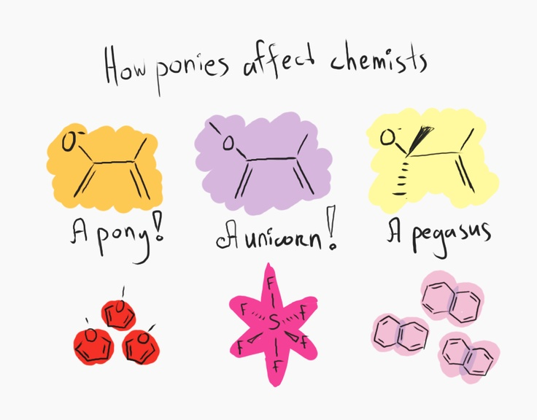

# PLEASE DO NOT TURN THE PAGE UNTIL INSTRUCTED TO DO SO

#### TASK 6 PART A: Multiple Choice [15 marks]

**Mark your answers on the sheet provided.**

1.The general formula for noncyclic alkenes is:

1. CnH2n+2
2. CnH2n
3. CnH2n-2
4. CnHn+2

2. The IUPAC name of the compound CH3CHCH2CH2CH3

|

CH3

1. 3-methylpentane
2. 4-methylpentane
3. 2-methylpentane
4. methylpentane
5. Which one of the following compounds is saturated?
   1. CH2CH2
   2. CH3CHCH2
   3. C6H6
   4. (CH3)3CH

4. The addition of Br2 to cyclohexene gives:

1. 1,2 – bromocyclohexene
2. bromocyclohexane
3. 1 – bromocyclohexene
4. 1,2 – dibromocyclohexane

5. Petrol consists of compounds with which number of carbon atoms in its molecules?

* 1. C1 to C5
  2. C6 to C10
  3. C11 to C12
  4. C13 to C25

6. The correct formula for copper (II) phosphate

     a)  Cu3(PO3)2  
     b)  Cu2PO3  
     c)  Cu3(PO4)2  
     d)  Cu2(PO4)3

7. Which of the following compounds does not exist in two or more structural forms?

1. C4H10
2. C2H4Cl2
3. C2HCl3
4. C2H2Cl2

8. The products of the balanced equation for the combustion of propane in plentiful air are:

1. 2CO2 + 4H2O
2. 3CO + 4H2O
3. 3CO2 + 4H2O
4. 3CO2 + 8H2O

9. A compound mistakenly named 3,4 – dimethylbutane should be named correctly,

according to IUPAC rules as:

1. 2,3 – dimethylbutane
2. 2 – methylpentane
3. 1,2 – dimethylbutane
4. 3 – methylpentane
5. Two organic compounds are structural isomers of each other if they

a) have the same molecular formula but different structural formulae.

b) have the same structure in the solid state but different melting temperatures.

c) differ from each other by a CH2 unit.

d) have the same physical properties but different molecular formulae.

11. Which of the following equations is NOT balanced?

a) 2H2S(g) + 3O2(g) 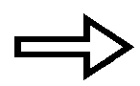 2H2O(g) + 2SO2(g)

b) 2C2H6(g) + 7O2(g)  4CO2(g) + 6H2O(g)

c) HCl(aq) + NaOH(aq)  H2O(l) + NaCl(aq)

d) 3NO(g) + 2O2(g)  3NO2(g)

12. Two compounds which have the same molecular formulae, but different structural

formulae are:

* 1. 1-chloropropane and 3-chloropropane.
  2. butanal and butanone.
  3. propane and propene.
  4. butane and 1-methylpropane.

13. How many isomers are there for C3H6Cl2?

1. 3
2. 4
3. 5
4. 6

14. Which of the following statements is **FALSE** for the chemical equation given

below in which nitrogen gas reacts with hydrogen gas to form ammonia gas assuming the reaction goes to completion?

N2 + 3H2 ➔ 2NH3

1. The reaction of one molecule of H2 will produce 2/3 molecule of NH3.
2. One molecule of N2 will produce two molecules of NH3.
3. One molecule of nitrogen requires three atoms of hydrogen.
4. To produce one molecule of NH3 you require 1/2 molecule of N2.

15. For which of the compounds below are cis-trans isomers possible?

|  |  |  |
| --- | --- | --- |
| CH3CH=CH2 | CH3CH=CHCH2CH3 | CH3CH=CHCH3 |
| (1) | (2) | (3) |

1. only 2
2. both 1 and 2
3. both 2 and 3
4. all three

#### TASK 6 PART B: Short Answer [20 marks]

**Mark your answers on the sheet provided.**

1. Distinguish between saturated and unsaturated hydrocarbons, providing

examples of each. (2 marks)

2. Draw structural formula of each of the following organic compounds:

(you must show all hydrogens) (4 marks)

|  |  |
| --- | --- |
| Name | Structural formula |
| 3,3 – dimethylpentane |  |
| cis – 1,2 – dibromoethene | Do not write in this section |
| 1,3,5 – triiodocyclohexane |  |
| 6 – chloro – 4 – methyl – 1 –heptene |  |

3. Write balanced equations for the reactions between the following substances: (3 marks)

1. Propene and hydrogen gas in the presence of a metal catalyst.
2. Methane and bromine gas
3. 1-butene and hydrogen chloride gas

4. a) How are fossil fuels formed? (1 mark)

b) Give two examples of fossil fuels. (1 mark)

c) Name two drawbacks of using fossil fuels for energy. (1 mark)

5. Name the following organic compounds according to IUPAC rules: (5 marks)

|  |  |
| --- | --- |
| Structural formula | IUPAC name |
| CH3    CH3 |  |
| CH3CH2CHClCH3 |  |
| F  Do not write in this section  |  CH3CHCHCH3  |  CH2  |  CH3 |  |
| H  |  CH3C=CCH2CH3  |  H |  |
| CH2CH3  Br |  |

6. Balance the chemical equations given in the answer booklet. If the equation is already balanced then write the word “balanced” next to the equation. (3 marks)

**TASK 7 - EXTENDED RESPONSE** (SCIENCE AS A HUMAN ENDEAVOUR 2)

NANOTECHNOLOGY (10 marks)

In 1857 Michael Faraday experimented with nanostructured gold (colloidal gold). Explain

what colloidal gold is in terms of its physical properties and use. What risks does the

use of nanomaterials have to health, safety and the environment and what regulations are

being developed in response to these risks.



**NAME:__________________________________**

**AECHE11**

**ORGANIC CHEMISTRY and CHEMICAL REACTIONS**

**TASK 6** Part A : Multiple Choice Answer Sheet

Part B : Short Answer Questions

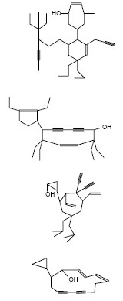

**TASK 7**

Part C : Research Assignment 2 (SHE 2)

|  |  |
| --- | --- |
| Section | Marks |
|  |  |
| Part A | /15 |
| Part B | /25 |
|  |  |
| Part C | /10 |

# PLEASE DO NOT TURN THE PAGE UNTIL INSTRUCTED TO DO SO

**PATR A : MULTIPLE CHOICE ANSWER SHEET**

INSTRUCTIONS

For each question shade the box to indicate the answer.

|  |  |  |  |  |
| --- | --- | --- | --- | --- |
| 1. | a 🞏 | b ◼ | c 🞏 | d 🞏 |

Use **only** a blue or black pen to **shade** the boxes.

For example, if b is your answer

X

If you make a mistake, place a cross through that square, do not erase or use correction fluid.

|  |  |  |  |  |
| --- | --- | --- | --- | --- |
| 1. | a 🞏 | b ◼ | c 🞏 | d ◼ |

Shade your new answer.

For example, if b is a mistake and d is your correct answer:

In the event that you then change your mind back to your original answer, you then cross out the second selection and then circle the first choice.

X

X

For example, if b was the first choice and d your second, but you change your mind back and b is your answer:

|  |  |  |  |  |
| --- | --- | --- | --- | --- |
| 1. | a 🞏 | b ◼ | c 🞏 | d ◼ |

Marks will **not** be deducted for incorrect answers. No marks will be given if more than one answer is completed for any question.

|  |  |  |  |  |
| --- | --- | --- | --- | --- |
| 1. | a 🞏 | b 🞏 | c 🞏 | d 🞏 |
| 2. | a 🞏 | b 🞏 | c 🞏 | d 🞏 |
| 3. | a 🞏 | b 🞏 | c 🞏 | d 🞏 |
| 4. | a 🞏 | b 🞏 | c 🞏 | d 🞏 |
| 5. | a 🞏 | b 🞏 | c 🞏 | d 🞏 |
| 6. | a 🞏 | b 🞏 | c 🞏 | d 🞏 |
| 7. | a 🞏 | b 🞏 | c 🞏 | d 🞏 |
| 8. | a 🞏 | b 🞏 | c 🞏 | d 🞏 |
| 9. | a 🞏 | b 🞏 | c 🞏 | d 🞏 |
| 10. | a 🞏 | b 🞏 | c 🞏 | d 🞏 |

|  |  |  |  |  |
| --- | --- | --- | --- | --- |
| 11. | a 🞏 | b 🞏 | c 🞏 | d 🞏 |
| 12. | a 🞏 | b 🞏 | c 🞏 | d 🞏 |
| 13. | a 🞏 | b 🞏 | c 🞏 | d 🞏 |
| 14. | a 🞏 | b 🞏 | c 🞏 | d 🞏 |
| 15. | a 🞏 | b 🞏 | c 🞏 | d 🞏 |

/15

**Short Answer Questions**

Answer all questions in the spaces provided. (Total 20 marks)

1. (2 marks)

___________________________________________________________________________________

___________________________________________________________________________________

___________________________________________________________________________________

___________________________________________________________________________________

___________________________________________________________________________________

2. (4 marks)

|  |  |
| --- | --- |
| Name | Structural formula |
|  |  |
| Do not write in this section |  |
|  |  |
|  |  |

3. (3 marks)

_________________________________________________________________________________

_________________________________________________________________________________

_________________________________________________________________________________

4.

a) (1 mark)

___________________________________________________________________________________

___________________________________________________________________________________

b) (1 mark)

i) ___________________________________________

ii) __________________________________________

c) (1 mark)

i) ___________________________________________

ii) __________________________________________

5. (5 marks)

|  |  |
| --- | --- |
| Structural formula | IUPAC name |
|  |  |
| Do not write in this section |  |
|  |  |
|  |  |
|  |  |

6. (3 marks)

a) P4 +  O2 →  P2O5

b)      Al2O3 →  Al +  O2

c) Ca(OH)2 +  H3PO4 →  Ca3(PO4)2 +  H2O

1. C2H2 +  O2 →  CO2 +  H2O

e) AgNO3 +  K3PO4 →  Ag3PO4 +  KNO3

f) Al2(SO4)3 +  Ca(OH)2 →  Al(OH)3 +  CaSO4

**TASK 7 - EXTENDED RESPONSE** (SCIENCE AS A HUMAN ENDEAVOUR 2)

NANOTECHNOLOGY (TOTAL : 10 marks)

What is Colloidal Gold : (1 mark)

|  |
| --- |
|  |
|  |
|  |
| Colour of large particles: _____________________ (1 mark)  Colour of small particles: _____________________ (1 mark)  Physical properties: (1 mark) |
|  |
|  |
|  |
| Uses and explanation: (3 marks)  (i) _______________________________________________________________________ |
|  |
|  |
|  |
|  |
| (ii) _______________________________________________________________________ |
|  |
|  |
|  |
|  |
| Risks – Health and safety: (1 mark) |
|  |
|  |
|  |
|  |
|  |
|  |
|  |
| Risks – Environment: (1 mark) |
|  |
|  |
|  |
|  |
|  |
|  |
|  |
| Regulations: (1 mark) |
|  |
|  |
|  |
|  |

|  |
| --- |
|  |
|  |
|  |
|  |
|  |